**Custom Explainability Solution**

A **custom explainability solution** in machine learning refers to techniques that make complex models more understandable and interpretable to users by providing tailored explanations for specific use cases, models, or stakeholders.

**Purpose**: The goal is to provide relevant, accurate, and interpretable explanations that help stakeholders understand the model’s decision-making process, build trust, and detect potential biases or errors.

**Scenario: Explainability for Diabetes Prediction Model**

Context: A healthcare provider uses a machine learning model to predict patients' diabetes risk based on factors like glucose level, BMI, and age. They aim to provide tailored explanations for doctors, patients, and regulators**.**

**Challenges:**

* Doctors need detailed insights into each prediction to guide patient care.
* Patients want clear, actionable feedback on their health risks.
* Regulators require proof that the model is fair and unbiased.

**Solution:**

1. Doctors: A dashboard shows each feature's impact on the prediction (e.g., high glucose increases risk), with SHAP values detailing the contribution of each factor.
2. Patients: Simplified, actionable feedback (e.g., "Your risk is high; consider a healthier diet") helps them understand their health without technical jargon.
3. Regulators: Reports with SHAP-based fairness metrics across demographics ensure compliance with anti-discrimination standards and model transparency.

**Techniques for custom explainability solution**

import pandas as pd

from sklearn.model_selection import train_test_split

from sklearn.linear_model import LogisticRegression

from sklearn.metrics import accuracy_score

import shap

import matplotlib.pyplot as plt

# Load the custom dataset

data = pd.DataFrame({

"Glucose": [148, 85, 183, 89, 137, 116, 78, 115, 197, 125, 110, 168, 139, 189, 166],

"BMI": [33.6, 26.6, 23.3, 28.1, 43.1, 25.6, 31.0, 35.3, 30.5, 0.0, 37.6, 38.0, 27.1, 30.1, 25.8],

"Age": [50, 31, 32, 21, 33, 30, 26, 29, 53, 54, 30, 34, 57, 59, 51],

"Outcome": [1, 0, 1, 0, 1, 0, 1, 0, 1, 1, 0, 1, 0, 1, 1]

})

# Separate features and target

X = data.drop("Outcome", axis=1)

y = data["Outcome"]

# Split into training and testing data

X_train, X_test, y_train, y_test = train_test_split(X, y, test_size=0.2, random_state=42)

# Train logistic regression model

model = LogisticRegression(max_iter=200)

model.fit(X_train, y_train)

# Predict and calculate accuracy for Model Regulator's report

y_pred = model.predict(X_test)

accuracy = accuracy_score(y_test, y_pred)

# Create a SHAP explainer

explainer = shap.Explainer(model, X_train)

# Select a single sample from the test set (for example, the first instance)

new_sample = X_test.iloc[0]

# Calculate SHAP values for the selected sample

new_sample_shap_values = explainer(new_sample.values.reshape(1, -1))

# Predict the class for the selected sample

predicted_class = model.predict(new_sample.values.reshape(1, -1))[0]

# Function to generate reports and display plots based on user role

def generate_report(instance, shap_values_instance, prediction, role):

report = f"### Role: {role}\n"

report += f"**Decision:** {'Diabetes Positive' if prediction == 1 else 'Diabetes Negative'}\n\n"

report += "### Patient Data:\n"

report += f"- **Glucose:** {instance[0]}\n"

report += f"- **BMI:** {instance[1]}\n"

report += f"- **Age:** {instance[2]}\n\n"

if role == "Patient":

report += ("### Explanation for Patients:\n"

"Your risk of diabetes is predicted based on your health indicators. "

"A higher glucose level, BMI, or age can increase the risk of diabetes.\n")

print(f"\nGenerated Report for Patient:\n{report}\n")

# Display SHAP Force Plot for Patient

print("SHAP Force Plot for Patient:")

shap.force_plot(explainer.expected_value, shap_values_instance, instance, feature_names=X.columns, matplotlib=True)

plt.show()

elif role == "Doctor":

report += ("### Explanation for Doctors:\n"

"The prediction is based on glucose levels, BMI, and age as key indicators for diabetes risk.\n")

print(f"\nGenerated Report for Doctor:\n{report}\n")

# Display SHAP Waterfall Plot for Doctor

print("SHAP Waterfall Plot for Doctor:")

shap.waterfall_plot(new_sample_shap_values[0])

plt.show()

elif role == "Model Regulator":

report += ("### Explanation for Model Regulators:\n"

"This model's accuracy on the test set is a critical performance indicator.\n")

report += f"- **Model Accuracy:** {accuracy:.2f}\n"

print(f"\nGenerated Report for Model Regulator:\n{report}\n")

# Generate and display reports for each role

for role in ["Patient", "Doctor", "Model Regulator"]:

generate_report(new_sample.values, new_sample_shap_values.values[0], predicted_class, role)

Output:

Generated Report for Patient:

### Role: Patient

**Decision:** Diabetes Negative

### Patient Data:

- **Glucose:** 125.0

- **BMI:** 0.0

- **Age:** 54.0

### Explanation for Patients:

Your risk of diabetes is predicted based on your health indicators. A higher glucose level, BMI, or age can increase the risk of diabetes.

SHAP Force Plot for Patient:

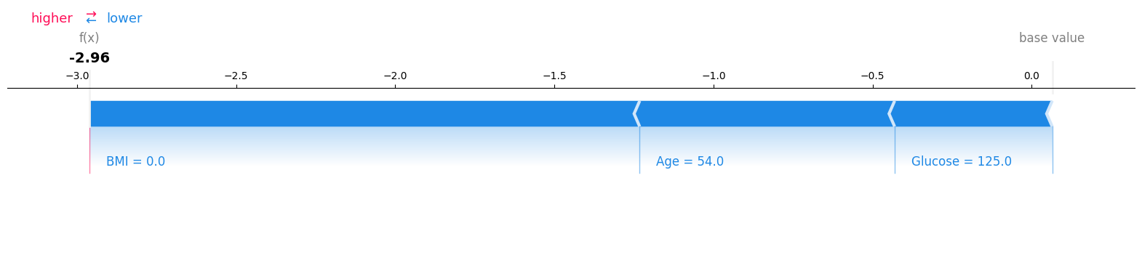

Generated Report for Doctor:

### Role: Doctor

**Decision:** Diabetes Negative

### Patient Data:

- **Glucose:** 125.0

- **BMI:** 0.0

- **Age:** 54.0

### Explanation for Doctors:

The prediction is based on glucose levels, BMI, and age as key indicators for diabetes risk.

SHAP Waterfall Plot for Doctor:

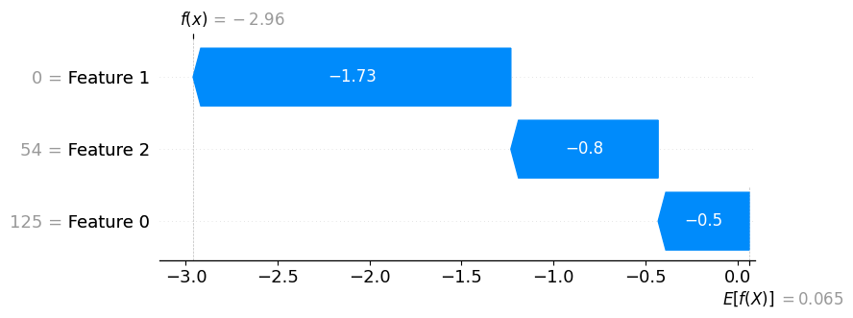

Generated Report for Model Regulator:

### Role: Model Regulator

**Decision:** Diabetes Negative

### Patient Data:

- **Glucose:** 125.0

- **BMI:** 0.0

- **Age:** 54.0

### Explanation for Model Regulators:

This model's accuracy on the test set is a critical performance indicator.

- **Model Accuracy:** 0.67

Difference between custom explainability solution and explainability:

